**Peng Chen**

Assistant Professor of Advanced Materials Thrust, Function Hub, HKUST(GZ)

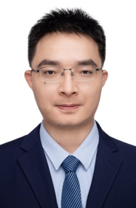

Email: pengchen@ust.hk

**Research Interests**

Prof. Peng Chen is devoted to studying atomic/molecular quantum systems with high controllability. In the QST center, Prof. Peng Chen’s team is working on interdisciplinary topics in experimental quantum information sciences, including (1) quantum optics with optical tweezers arrays, (2) novel quantum effects with quantum few-body systems, (3) quantum entanglement and network.

**Biography**

Prof. Chen obtained his PhD degree from Shanghai institute of optics and fine mechanics, the Chinese academy of sciences. He received his bachelor’s degree from Harbin university of science and technology. Before joining HKUST (GZ), he worked as a senior researcher at Hefei national laboratory for physical sciences at the microscale, Shanghai branch of university of science and technology (2015-2018), and research assistant professor in HKUST (2019-2022). Prof. Chen has extensive research experiences in diverse experimental fields of atomic, molecular, and optical physics, including quantum optics, ultracold atoms, Rydberg atoms, quantum metrology and surface optics. His research works have been published in top peer-reviewed journals including nature communications, physical review letters, Optica, etc. He is a member of ﻿Youth Innovation Promotion Association, the Chinese Academy of Sciences.

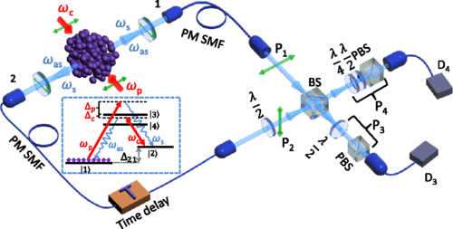

Figure 1: Time-resolved and polarization dependent narrowband two-photon interference

Figure 2: Compact ﻿two-dimensional magneto-optical trap as a source for

cold strontium atoms